**Construct:**

FSM id (ℓ (ℓ | d)* ℓ | ℓ)

FSM real d+, d+

FSM int d+

FSM keywords while (check identifiers against list of keywords)

FSM separators , : (check whether that character is part of separators list)

FSM operators + - * divide (check character operators, < >)

**Machines:**

(ℓ (ℓ | d)* ℓ | ℓ)

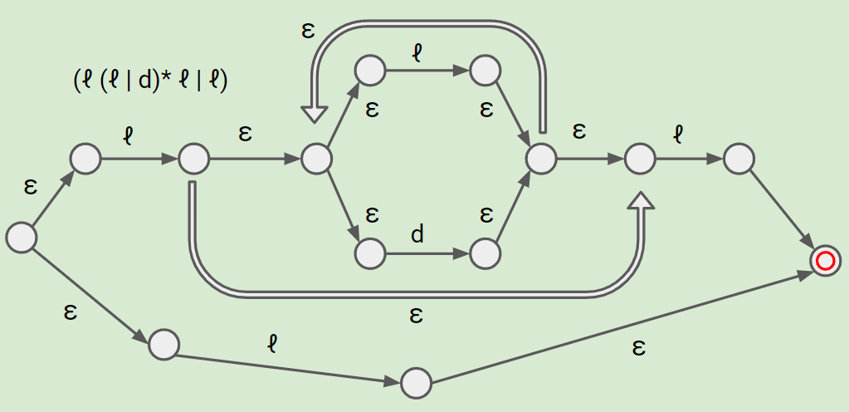

d+

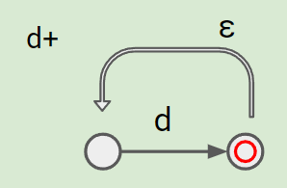

**NFSM to DFSM Conversion for Identifier**

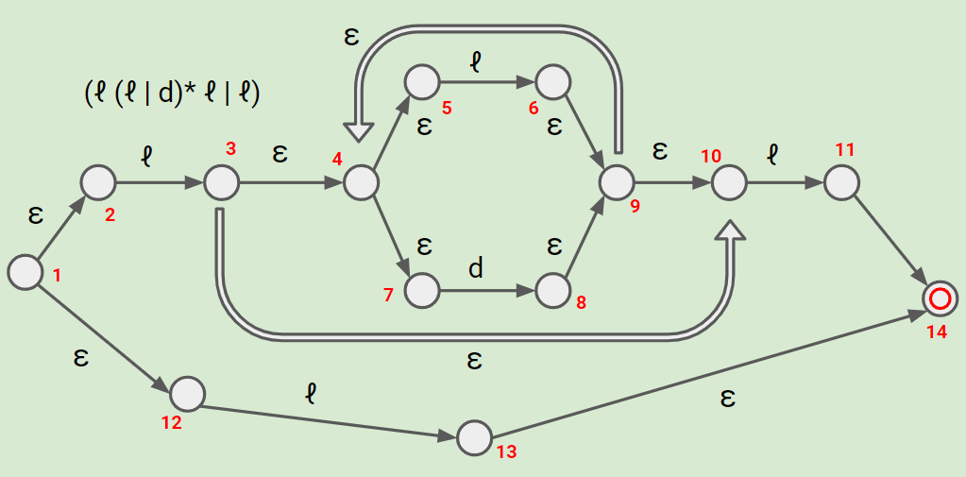

**Epsilon-Closures:**

(1) = {1, 2, 12}

(2) = {2}

(3) = {3, 4, 5, 7, 10}

(4) = {4, 5, 7}

(5) = {5}

(6) = {6, 9, 4, 5, 7, 10}

(7) = {7}

(8) = {8, 9, 4, 5, 7, 10}

(9) = {9, 4, 5, 7, 10}

(10) = {10, 4, 5, 7}

(11) = {11, 14}

(12) = {12}

(13) = {13, 14}

(14) = {14}

**DFSM Conversion**

(Bolded Red: Accepting States)

| q0 = [1] | letter | digit |
| --- | --- | --- |
| ~~[1]~~ **[1, 2, 12]** | ~~[3, 13]~~ [3, 4, 5, 7, 10, 13, 14] | [ ] |
| [3, 4, 5, 7, 10, 13, 14] | ~~[6, 11]~~ [6, 9, 4, 5, 7, 10, 11, 14] | ~~[8]~~ [8, 9, 4, 5, 7, 10] |
| [6, 9, 4, 5, 7, 10, 11, 14] | ~~[6, 11]~~ [6, 9, 4, 5, 7, 10, 11, 14] | ~~[8]~~ [8, 9, 4, 5, 7, 10] |
| **[8, 9, 4, 5, 7, 10]** | ~~[11]~~ [11, 14] | ~~[8]~~ [8, 9, 4, 5, 7, 10] |
| **[11, 14]** | [ ] | [ ] |

**NFSM to DFSM Conversion for int (same machine)**

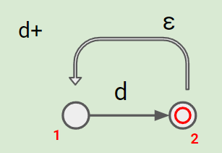

**Epsilon-Closures:**

(1) = {1}

(2) = {2, 1}

**DFSM Conversion**

(Bolded Red: Accepting States)

| q0 = [1] | digit |
| --- | --- |
| ~~[1]~~ [1] | ~~[2]~~ [2, 1] |
| **[2, 1]** | [ ] |